[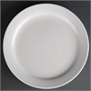](http://www.nisbets.co.uk/Athena-Hotelware-Narrow-Rimmed-Plates-6-1$2-in/CF360/ProductDetail.raction) 6 ½” Plate £6.50 per dozen

[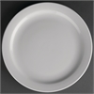](http://www.nisbets.co.uk/Athena-Hotelware-Narrow-Rimmed-Plates-9-in/CF363/ProductDetail.raction) 9” Plate £6.50 per dozen

[](http://www.nisbets.co.uk/Athena-Hotelware-Narrow-Rimmed-Plates-11-in/CF365/ProductDetail.raction) 11” Plate £6.50 per dozen

[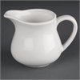](http://www.nisbets.co.uk/Athena-Hotelware-Milk-Jugs-6oz/CF370/ProductDetail.raction) 6oz Milk Jug £6.50 per dozen

[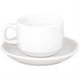](http://www.nisbets.co.uk/SPECIAL-OFFER-Athena-Stacking-Tea-Cup-And-Saucer-Combo/S376/ProductDetail.raction)[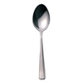](http://www.nisbets.co.uk/Olympia-Harley-Teaspoon/D697/ProductDetail.raction) Cup, saucer and spoon £7.50 per dozen

[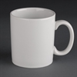](http://www.nisbets.co.uk/Athena-Hotelware-Mugs-10oz/CC203/ProductDetail.raction) 10oz mug £6.50 per dozen

[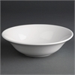](http://www.nisbets.co.uk/Athena-Hotelware-Oatmeal-Bowls-6-in/CC213/ProductDetail.raction) 6” Oatmeal bowls £6.50 per dozen

[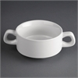](http://www.nisbets.co.uk/Athena-Hotelware-Stacking-Soup-Bowls-10oz/CF369/ProductDetail.raction) Soup bowls £6.50 per dozen

[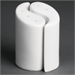](http://www.nisbets.co.uk/Olympia-Ying-Yang-Salt-and-Pepper-Sets-95mm/Y107/ProductDetail.raction) Sal and Pepper set £2.95 each

[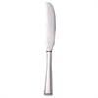](http://www.nisbets.co.uk/Olympia-Harley-Table-Knife/D690/ProductDetail.raction)[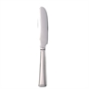](http://www.nisbets.co.uk/Olympia-Harley-Dessert-Knife/D693/ProductDetail.raction)Table Knives / Dessert Knives £4.50 per dozen

[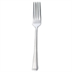](http://www.nisbets.co.uk/Olympia-Harley-Table-Fork/D691/ProductDetail.raction)[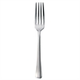](http://www.nisbets.co.uk/Olympia-Harley-Dessert-Fork/D694/ProductDetail.raction)Table Forks / Dessert Forks £4.50 per dozen

[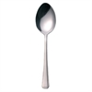](http://www.nisbets.co.uk/Olympia-Harley-Dessert-Spoon/D695/ProductDetail.raction)[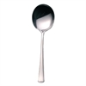](http://www.nisbets.co.uk/Olympia-Harley-Soup-Spoon/D696/ProductDetail.raction)Dessert spoon / soup spoon £4.50 per dozen

[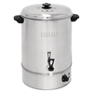](http://www.nisbets.co.uk/Buffalo-Manual-Fill-Water-Boiler-40Ltr/GL349/ProductDetail.raction) £30.00

The manual fill water boiler is a powerful and versatile appliance.

**[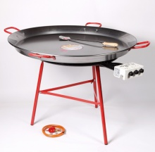](http://www.thepaellacompany.co.uk/catering-size-sets.html)** 70cm pan / Burner / Stand / large spoon £120.00

1000cm pan / Burner / Stand / large spoon £140.0

**[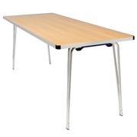](http://www.gopak.co.uk/tables/folding-tables)** Folding go-pack table 6-foot table £20

[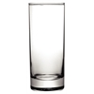](http://www.nisbets.co.uk/Olympia-Hi-Ball-Glasses-340ml-x48/CB715/ProductDetail.raction) Hi Ball £5.95 per dozen

Versatile, straight-sided glasses which are perfect for all sorts of drinks, in all sorts of environments

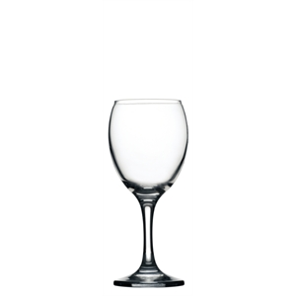[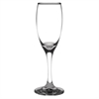](http://www.nisbets.co.uk/Olympia-Solar-Champagne-Flutes-170ml/DL887/ProductDetail.raction)Wine or Champagne £5.95 per dozen

Classic, single-piece construction glass with curved stem Stronger and tougher than standard economy products, the Imperial wine glass looks great behind any bar and on any table.

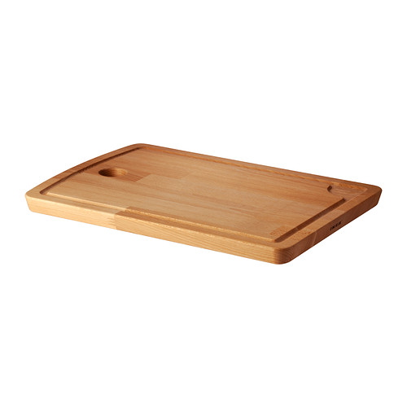 £3.00 each

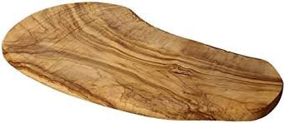 £5.00 each

The presentation for charcuterie / chopping board collects meat and juice in the milled groove and prevents it from spilling on to your worktop **Size** 38x27 cm

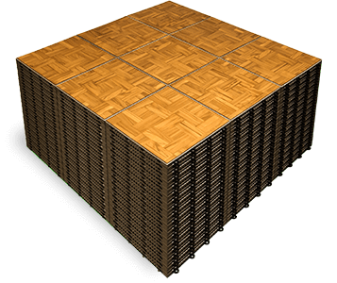Teak

**12-foot x 9-foot dance floor with black edge**

**Includes delivery/ collection and assembly £150.00**

If you can’t see what you need, please call Matthew on 07797726366 as we might have it in stock

***Hire price is based on a 48-hour period***

***Collection FOC from St Brelades***

***Delivery/Collection charges***

***St Brelades £15.00***

***St Peter / St Ouens / St Marys £20.00***

***St Johns / St Lawrence / St Helier £25.00***

***St Saviour / St Clements / Trinity / St Martins / Grouville £30.00***

***Glass/Plate cleaning can be arranged***

***Broken/missing glass wear £2.50 per item***